Appendix B--Standard apparatus operation communications.
When fire fighters ride in the tiller's seat or other remote location, an electrical signal or voice communication should be installed between the tiller's seat, work station, and driver's compartment.
(1) These signals should be used between the driver and the fire fighters:
(a) One long buzz means stop;
(b) Two buzzes mean forward;
(c) Three buzzes mean reverse.
(2) Before any of the above functions are undertaken, with the exception of stopping, the same signal must be both sent and received. The driver should not act without sending and receiving a confirming signal.
(3) When using hand signals, these signals are as follows:
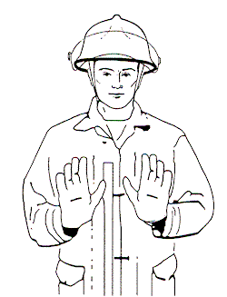
STOP
Hold hand to the side, shoulder high, exposing
palm to the driver. At night, hold hands in the
same manner, with the addition of a flashlight
in one hand shining at the driver. This will
indicate and immediate STOP
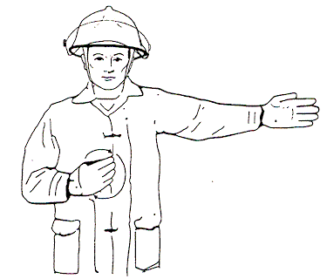
RIGHT OR LEFT
Point in the desired direction with one hand
and motion in a circular “come-on” gesture with the
other at the chest level. At night, direct a flashlight beam
at the hand pointing in the desired direction.
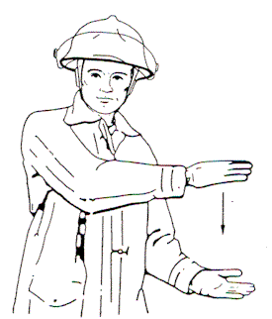
DIMINISHING CLEARANCE
Hold the hands to one side of the body indicating the approximate
amount of distance the apparatus is from the obstacle.
Close hands accordingly as the driver slowly maneuvers the apparatus
to point where the signal indicates immediate STOP. Always allow enough
for drivers reaction time. At night, indicate in the same manner with
the flashlight in the upper hand and beam directed at the palm of the other.
On STOP, cover the flashlight beam with the hands.
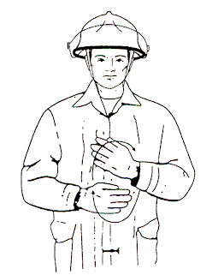
AHEAD OR BACK UP
Hold hand directly in front, chest high, fingers
on hands directed toward one another, and
motion in a circular “come-on” gesture.
At night hold a flashlight in one hand and
direct the beam toward the other.
[Statutory Authority: RCW 49.17.010, [49.17].050 and [49.17].060. 96-11-067, § 296-305-08000, filed 5/10/96, effective 1/1/97.]

